Exercise (Instructions):

HTTP: Get /Post/Put/Delete

<https://jsonplaceholder.typicode.com/posts>

Objectives and Outcomes

In this exercise you will get familiar with Event & Binding using ngModel.

At the end of this exercise you will be able to:

* Create a submit form
* Create and bind data with an event
* Submit data to services

Clone the project MyBlogApplication from here:

<https://github.com/DuongPT4/MyBlogApplication.git>

from the downloaded location, open cmd. Install node server:

*npm init*

*npm install lite-server*

to run the application, in the cmd type:

*ng serve --open*

Access to page:

<https://jsonplaceholder.typicode.com/posts>

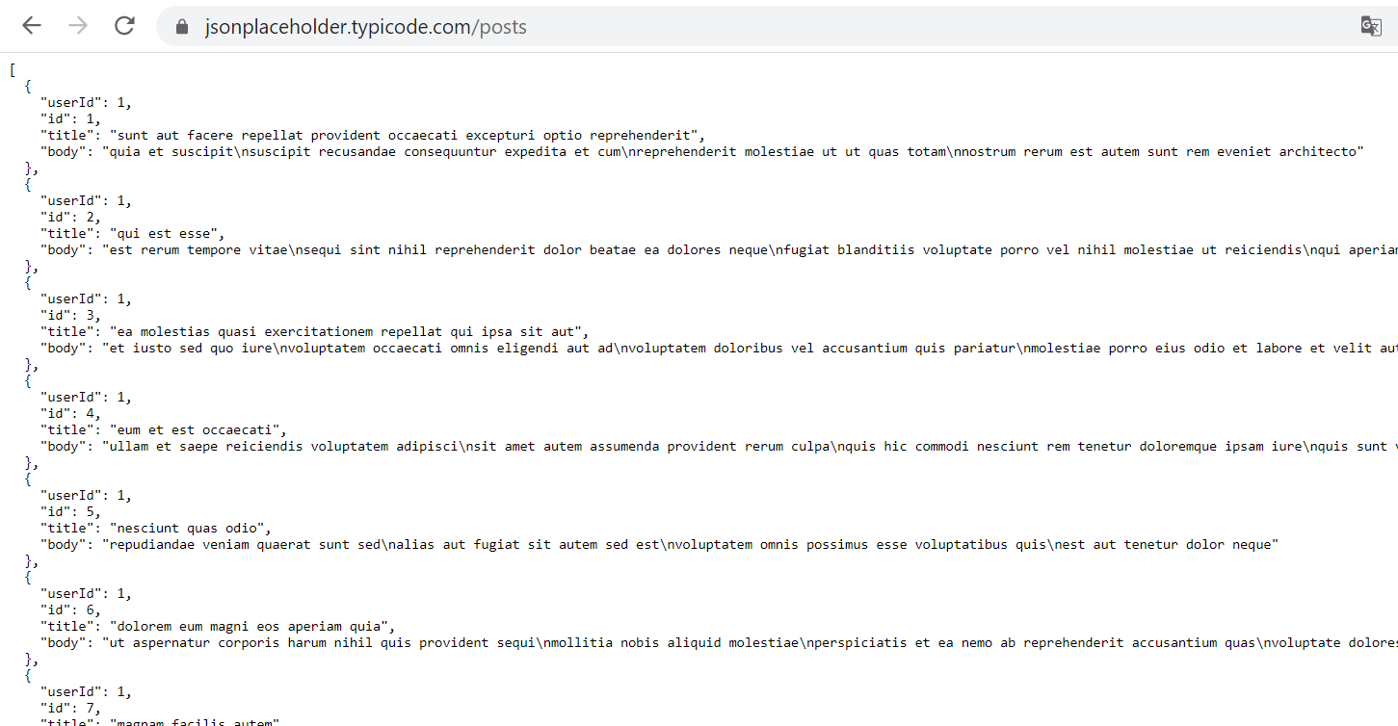

edit post.ts

export class Post{

    id: number;

    userid?: number;

    title: string;

    body: string;

}

To install HttpModule, type the following in the command line:

*npm install -g @angular/common*

*Change code of post.service.ts*

import {Injectable} from '@angular/core';

import {Post} from './post';

import {HttpClient} from '@angular/common/http';

import { Observable } from 'rxjs';

@Injectable()

export class PostService{

    private postUrl ='https://jsonplaceholder.typicode.com/posts';

    constructor(private _http:HttpClient){

    }

    getPost():Observable<Post[]>{

        return this._http.get<Post[]>(this.postUrl);

    }

    addPost(post:Post){

        console.log("Post added here");

    }

   /*  getPost():Promise<Post[]>{

        return Promise.resolve(POSTS);

    }

    addPost(post:Post){

        POSTS.push(post);

    } */

}

*Change code app.component.ts*

export class AppComponent {

  posts : Post[];

  title: string;

  body: string;

  constructor(private _postService : PostService){

    _postService.getPost().subscribe(ps => this.posts=ps);

   /*  _postService.getPost().then(

      ps => {this.posts=ps;

      }); */

  }

  test(){

    console.log(this.title + this.body);

  }

  addPost(){

    var newPost = {

      id: 0,

      title: this.title,

      body: this.body

    }

    this._postService.addPost(newPost);

  }

}

*Import HttpModule to app.module.ts*

import { BrowserModule } from '@angular/platform-browser';

import { NgModule } from '@angular/core';

import {FormsModule} from '@angular/forms';

import {HttpClientModule} from '@angular/common/http';

import { AppComponent } from './app.component';

@NgModule({

  declarations: [

    AppComponent

  ],

  imports: [

    BrowserModule,

    FormsModule,

    HttpClientModule

  ],

  providers: [],

  bootstrap: [AppComponent]

})

export class AppModule { }

*Run the app*

